Name: Abdulelah Ali Alturki

ID: 2136110

Date: 12/1/2024

**Project Idea (Problem Definition)**

There’s no efficient way to browse and purchase books online that cater to all reader preferences, from classic literature lovers to sci-fi enthusiasts. Existing platforms often lack personalized recommendations.

**Recommended Solution**

Create a website that offers a diverse book selection, from timeless classics like Pride and Prejudice to popular sci-fi titles like Dune. The site would feature personalized recommendations, best-sellers, and customer favorites.

**Benefits of the Provided Solution**

This solution provides an easy-to-navigate platform where users can quickly find books suited to their tastes, leading to a more engaging shopping experience and faster discovery of new reads.

Application URL:

<https://turkis-bookstore-production.up.railway.app/index.php>

**Story Board for Pages**

**Index page**

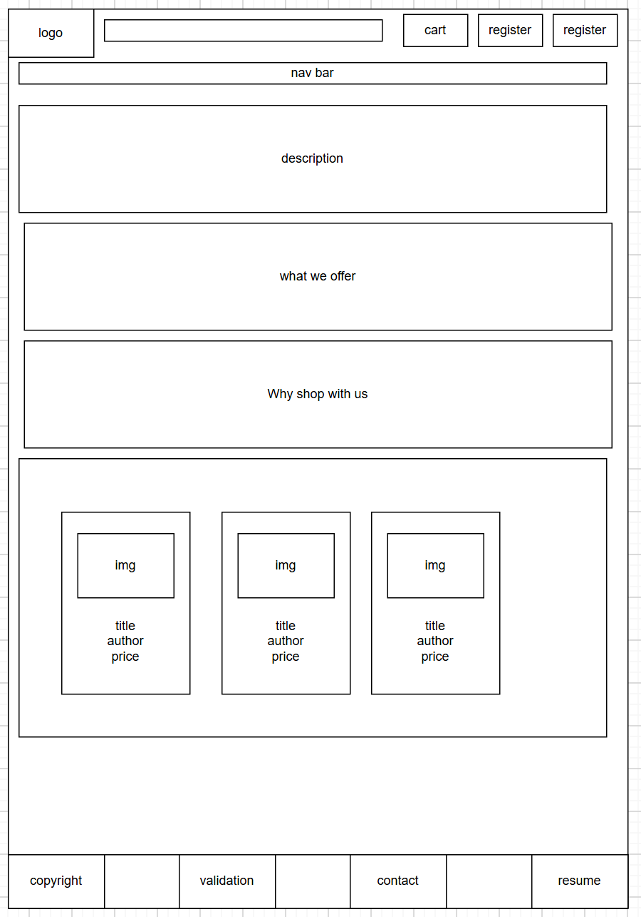

**Services page**

**Best Seller page**

**Favorites page**

**Contact page**

**Cart page**

**Upcoming events page**

**Author gallery page**

**Resume page**

**Login page**

**Register page**

**Book search page**

**Sitemap**

